Setup the MCP Environment

Create the separate environment with python 3.10 and activate the environment

Libraries:

1.Fast MCP

2.Fast API – to create api and wrap it up in the form of bundle then expose it to the outer world.

Version:





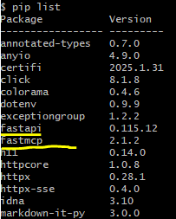

Create requirements.txt



Here we are going to create the server and inside the server we are going to create the tool. We have client then client will communicate with the server and then fetch some of the results.

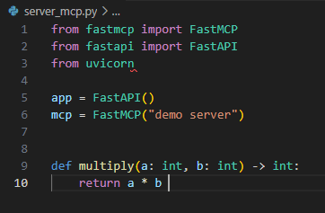

I want to treat this function as a tool and I want to expose this function with the help of MCP protocol.

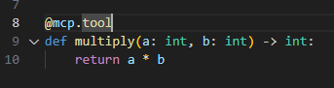

The next functionality is end point which will be called by my client.

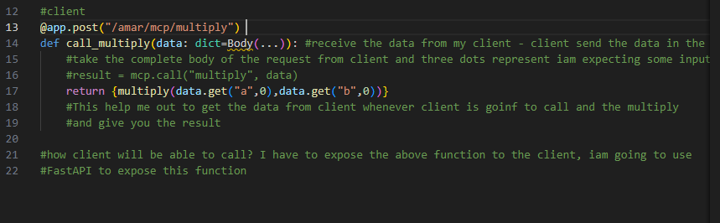

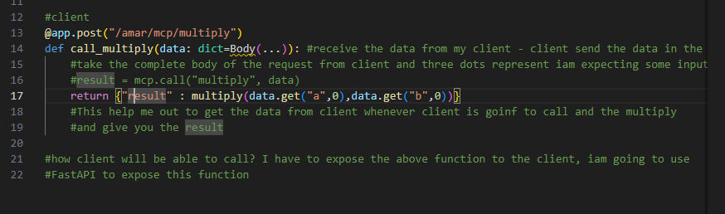

Now I can start my server

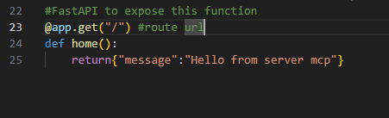

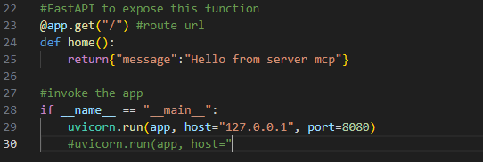

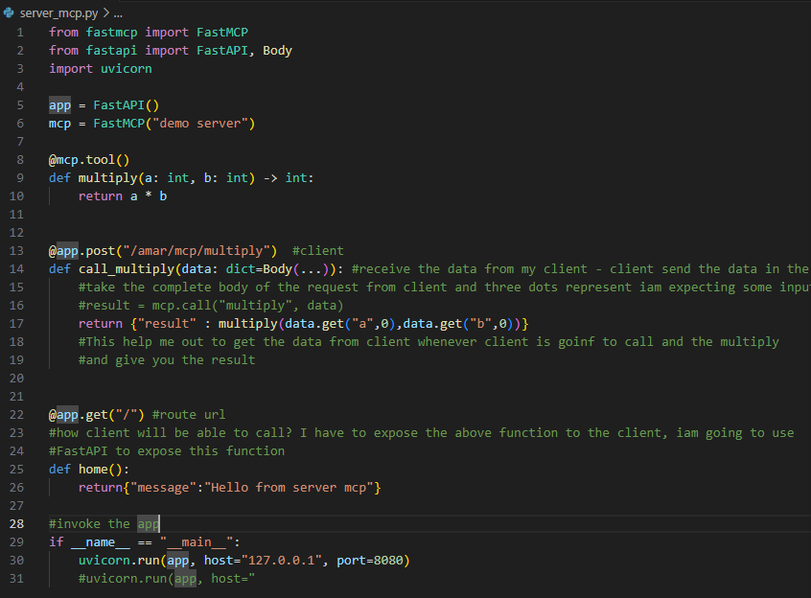

Now my server is ready to serve and now iam going to test the entire server

Inside the server I have one tool calling

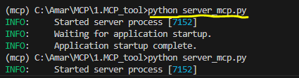



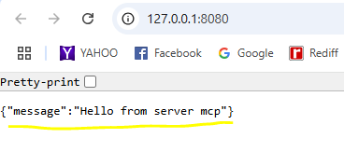

My server is up and ready to serve, I can use postman that can act as a client, API is behave as a client or even open AI behave as a client

Client.py

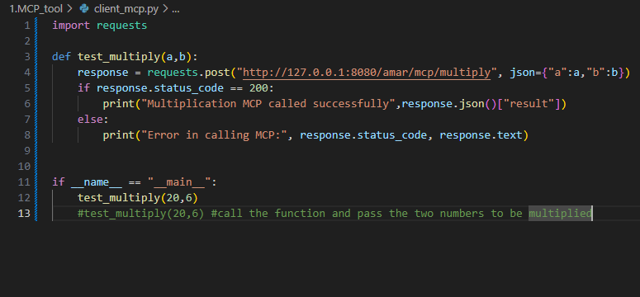

Make sure the server is also running on the another terminal.

